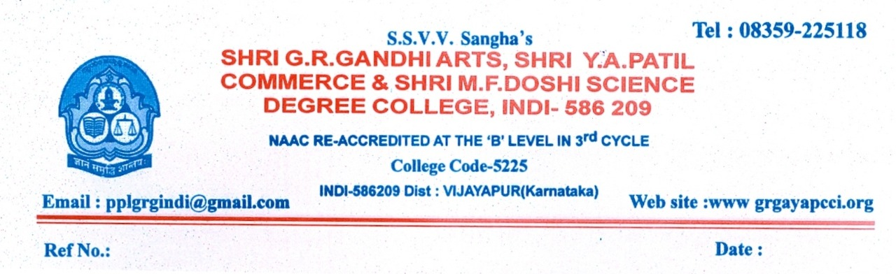
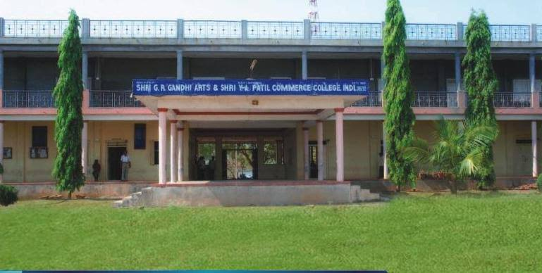
CRITERION VII - INSTITUTIONAL VALUES AND BEST PRACTICES
7.1.7 - The Institution has disabled-friendly, barrier free environment
1. Built environment with ramps/lifts for easy access to classrooms.
2. Disabled-friendly washrooms
3. Signage including tactile path, lights, display boards and signposts
4. Assistive technology and facilities for persons with disabilities (Divyangjan) accessible website, screen-reading software, mechanized equipment
5. Provision for enquiry and information : Human assistance, reader, scribe, soft copies of reading material, screen reading

POLICY FOR THE DIFFERENTLY ABLED

This policy has been prepared to ensure that all members of Shri GRG Arts, Shri YAP Commerce, Shri MFD Science Degree College are aware of the facilities provided for the people with disabilities. The college takes utmost care in providing the needed amenities and creates an environment of inclusive education for students.
- Assuring that buildings, toilets, libraries, etc. are barrier free and accessible for all types of differently abled persons.
- Ensuring inclusion and effectiveness in participation of differently abled students in curricular, co-curricular and extra-curricular activities.
- Providing assistance to the students in taking up the examinations.
- Updating the facilities available for differently abled students.
- Providing Parents – teachers counselling to the students.
- Ensuring that the differently abled persons have equal opportunities for sports and games.
- Every member of the college is made aware of the amenities and facilities available for the disabled and support them to access the in-house resources.

SELF DECLORATION

This is to declare that Shri GRG Arts, Shri YAP Commerce, Shri MFD Science Degree College, Indi. Is affiliated to Rani Chennamma University, Belagavi. And There are no Visually Impaired students admitted for the following programmes in the college.

SI.NO. | Name of the Programme | Number of Visually Impaired Students
01 | BA | 0
02 | B.CO | 0
03 | B.Sc | 0

